**Evolution of mitchondrial gene order in Onychophora**

Álvaro Vega Hidalgo, Bernal Morera Brenes, Federico Villalobos Brenes, Orlando Argüello Miranda, Tomas de Camino Beck

**Introduction**

The mitogenome of *Epiperipatus biolleyi* (Peripatidae) was the first onychophoran mitochondrial genome sequenced [(Podsiadlowski, Braband, & Mayer, 2008)](https://paperpile.com/c/dX1qLX/XVxK). Since this very first insight to the mitochondrial gene order of this basal phylum, during the ongoing debate Ecdysozoa/Articulata, the now widely accepted Ecdysozoa hypothesis [(Borner, Rehm, Schill, Ebersberger, & Burmester, 2014)](https://paperpile.com/c/dX1qLX/El3a) gained important support from the conserved blocks of gene boundaries shared by *E. biolleyi* and the Ancestral Arthropod Gene Order (AAGO) [(Lavrov, Boore, & Brown, 2000)](https://paperpile.com/c/dX1qLX/BOCB). Nevertheless, *E. biolleyi* mitochondrial gene order showed important rearrangements from the AAGO, which suggested that mitochondrial gene orders in Onychophora could be very diverse and derived from the AAGO. Any glimpse of the ancestral gene order of Onychophora remained unknown, until the mitogenome of *Opisthopatus cinctipes* (Peripatopsidae) was published [(Braband, Cameron, Podsiadlowski, Daniels, & Mayer, 2010)](https://paperpile.com/c/dX1qLX/ga6M). Its arrangement showed a complete correspondence with the AAGO in respect to protein-coding genes and some of the tRNA genes.

*Metaperipatus inae* mitochondrial gene order is the most derived known in Onychophora [(Braband, Podsiadlowski, Cameron, Daniels, & Mayer, 2010)](https://paperpile.com/c/dX1qLX/ovnC). This authors found through a manual analysis, that to produce such a derived arrangement from the ancestral arrangement of genes in Onychophora, at least two tandem-duplication-random-loss (TDRL) events had to happen, besides some rearrangements in the control regions.

Nine tRNA genes were missing at that time in *E. biolleyi*, and seven in *O. cinctipes*. At least two reasons could explain this missing tRNA genes. In a de novo genome annotation, the alignment of related tRNA sequences is an useful tool to infer gene positions. Hence, the position of the tRNA genes in these mitogenomes was difficult to determine, due to the lack of phylogenetic information (tRNAs of other onychophorans) available to align and search for the missing genes. Moreover, Segovia et al. (2011) found extensive post-transcriptional editions in tRNAs of onychophorans that are primarily transcribed from severely reduced tRNA genes, which make gene position inference very hard in this cases. Later, with the published mitogenomes of *Peripatoides* sp. (Peripatopsidae) and a second *E. biolleyi* [*(Rota-Stabelli et al., 2010)*](https://paperpile.com/c/dX1qLX/18RH), it was possible to determine the missing tRNAs in *E. biolleyi*. But the seven missing tRNA genes of *O. cinctipes* remain undiscovered.

The evolution of the mitochondrial gene order in Onychophora has been analyzed just by comparing the gene orders and trying to make guesses of the most parsimonious set of rearrangements, by eye. With only one exception (*M. inae*), this approach excluded the tandem-duplication-random-loss (TDRL) events, which have been demonstrated to be very common in the evolution of gene orders [(Podsiadlowski, Kohlhagen, & Koch, 2007)](https://paperpile.com/c/dX1qLX/ohmS). Consequently, due to the flaws of manual inference of rearrangements and the general necessity to provide repeatability, a systematic and numeric algorithm have been developed (i.e CREx and TreeREx). Hence, the objective of this study is to describe the evolution of the mitochondrial gene order in Onychophora and elucidate the evolution of mitochondrial gene orders.

**Materials and methods**

Phylogenetic analysis

To infer the mitochondrial genome rearrangements, a phylogenetic analysis was performed in order to have a topology in which the evolution of the gene orders can be analyzed. The species of interest were six onychophorans which are the only species of this phylum whose complete mitochondrial genome is available (*Epiperipatus biolleyi* and *Oroperipatus* sp. from Peripatidae and *Metaperipatus inae*, *Opisthopatus cinctipes*, *Peripatoides* sp. and *P. sympatrica* fromPeripatopsidae), plus two outgroup species of panarthropods (*Limulus polyphemus,* Arthropoda and *Thulinius* sp., Tardigrada) (Table 1).

The genes used for the analysis were 12S, 16S and COX1 (Table 1) which were downloaded and aligned using Geneious v8.0.5 [(Kearse et al., 2012)](https://paperpile.com/c/dX1qLX/38P3). For each species, two sequences per gene were used, excepting genes from *Oroperipatus* sp., *Thulinius* sp. and *Peripatoides* sp., in which only one sequence per gene was available. The best model of nucleotide substitution for each gene was selected using the Akaike Information Criterion [(Posada & Buckley, 2004)](https://paperpile.com/c/dX1qLX/9oHp) implemented in jModelTest v2.1.4 [(Darriba, Taboada, Doallo, & Posada, 2012; Guindon & Gascuel, 2003)](https://paperpile.com/c/dX1qLX/UXH8+4V0O). The selected models were: GTR+G for 12S, and GTR+G+I for 16S and COX1.

Phylogenetic analysis was performed using the *BEAST template incorporated in BEASTv2.3.2 [(Bouckaert et al., 2014; J. Heled & Drummond, 2009)](https://paperpile.com/c/dX1qLX/jMFt+Sa6w). *BEAST estimates the species tree using a Bayesian Markov chain Monte Carlo method for multispecies coalescent. This approach coestimates multigene trees embedded in a shared species tree, using a multilocus sample from multiple individuals per species. This Bayesian multilocus multi-individual phylogenetic analysis incorporated in *BEAST, have shown more accurate estimates of the species tree than other algorithms with the same purpose, and than the standard supermatrix method (concatenation) [(Joseph Heled, Joseph, & Drummond, 2008)](https://paperpile.com/c/dX1qLX/0L5f). Ten independent runs of the same dataset were performed using the strict clock model, with a chain length of 10 million generations and storing every 5000. LogCombiner was used to combine the trees and log files of the independent runs, discarding the first 100 000 generations of each as burn-in. TreeAnnotator and FigTree v1.4.2 enabled to create and visualize consensus trees, respectively.

Mitochondrial genome rearrangements

The complete mitochondrial genome sequences of the eight species of interest were downloaded. The gene order of these mitogenomes was extracted, including the control region. The tRNA genes were excluded due to the uncertainty of their position in species whose tRNA genes were not verified by retrotranscription; in the past, predicting the positions of tRNA genes has ended in almost complete failure, when not including retrotranscriptional information [(Segovia, Pett, Trewick, & Lavrov, 2011)](https://paperpile.com/c/dX1qLX/UJYp). This was caused by huge differences among the tRNA genes and the actual mature tRNA, due to the extensive post-transcriptional edition in onychophorans’ mitogenomes. The evolution of the GOs were analyzed using CREx [(Bernt et al., 2007)](https://paperpile.com/c/dX1qLX/gtq0) and TreeREx [(Bernt, Matthias, Daniel, & Martin, 2008)](https://paperpile.com/c/dX1qLX/jvS0), which have helped to preserve repeatability at the time of resolving questions on the evolution of mitogenome rearrangements of metazoa [(Babbucci, Basso, Scupola, Patarnello, & Negrisolo, 2014; Weigert et al., 2016; Xue, Guo, Dong, Hong, & Shao, 2016)](https://paperpile.com/c/dX1qLX/lizh+Q85W+jE9j).

CREx is a heuristic for computing pairwise rearrangement scenarios, based on strong common intervals along the GOs. This strong common intervals are gene intervals shared by two or more GOs which commute with any other common interval; given two intervals I and J, if either I ⊂ J, J ⊂ I, or I ∩ J = Ø, both intervals are said to commute. CREx considers transpositions, reversals, reverse transpositions, and tandem-duplication-random-loss (TDRL) events, which are from very difficult to impossible to determine by manual identification of rearrangements. This adds importance to this study, because hitherto, manual identification has been the only method used to describe the evolution of mitochondrial GOs in Onychophora.

The evolution of the mitochondrial GOs was inferred using TreeREx. This software uses a previously calculated species tree, to map the rearrangements of the GOs calculated by CREx, across the evolution of the species.

**Results**

Phylogenetic analysis

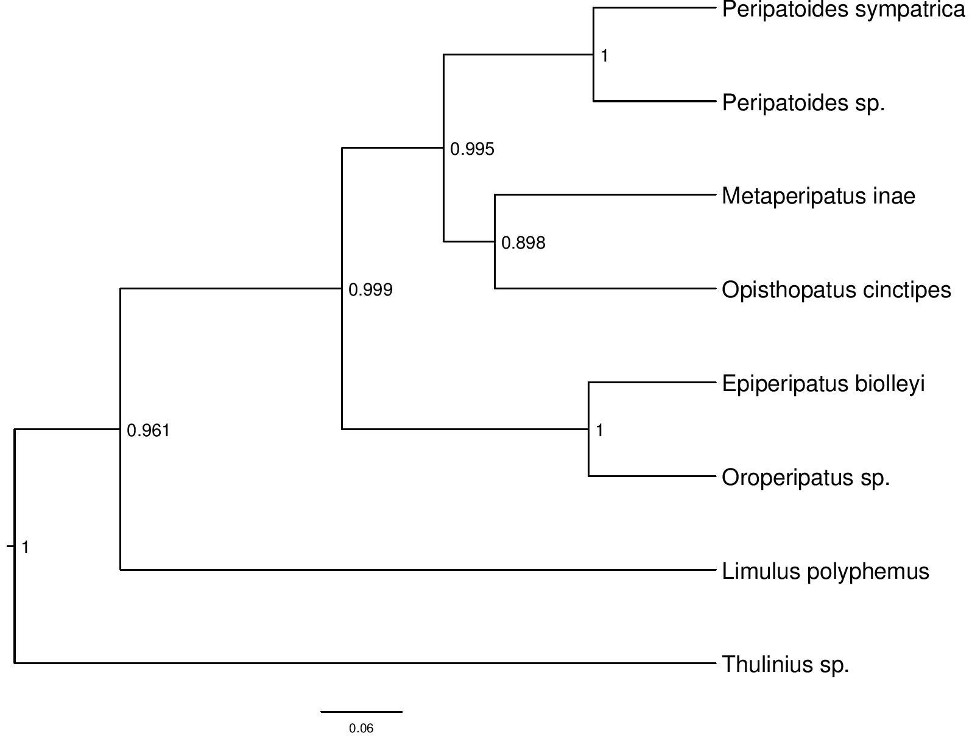

Figure 1. Phylogenetic tree­­­­­

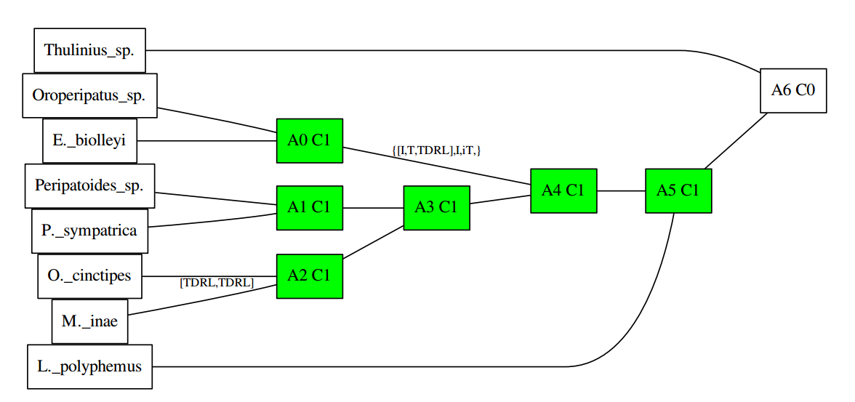

Figure 2. Rearrangements in the species of study

Table 1. Mitochondrial data used for phylogenetic analyses.

Bold accession numbers represent mitochondrial genomes used both for the rearrangement and phylogenetic analysis.

|  |  |  |  |  |  |  |
| --- | --- | --- | --- | --- | --- | --- |
| Phylum | Family | Species | COI | 16S | 12S | Reference |
| Onychophora | Peripatidae | *Epiperipatus biolleyi* | **DQ666064** | | | [(Podsiadlowski et al., 2008)](https://paperpile.com/c/dX1qLX/XVxK) |
| **HM600781** | | | [(Rota-Stabelli et al., 2010)](https://paperpile.com/c/dX1qLX/18RH) |
| *Oroperipatus* sp*.* | **JF800076** | | | [(Segovia et al., 2011)](https://paperpile.com/c/dX1qLX/UJYp) |
| Peripatopsidae | *Metaperipatus inae* | **EF624055** | | | [(Braband, Podsiadlowski, et al., 2010)](https://paperpile.com/c/dX1qLX/ovnC) |
| KC754659 | KC754541 | KC754490 | [(Murienne, Daniels, Buckley, Mayer, & Giribet, 2014)](https://paperpile.com/c/dX1qLX/zW2P) |
| *Opisthopatus cinctipes* | **HM008997** | | | [(Braband, Cameron, et al., 2010)](https://paperpile.com/c/dX1qLX/ga6M) |
| KC754674 | KC754556 | EU855506 | COI and 16S: [(Murienne et al., 2014)](https://paperpile.com/c/dX1qLX/zW2P) ; 12S: [(Daniels, Picker, Cowlin, & Hamer, 2009)](https://paperpile.com/c/dX1qLX/wwKt) |
| *Peripatoides* sp*.* | **HM600782** | | | [(Rota-Stabelli et al., 2010)](https://paperpile.com/c/dX1qLX/18RH) |
| *Peripatoides sympatrica* | **JF800075** | | | [(Segovia et al., 2011)](https://paperpile.com/c/dX1qLX/UJYp) |
| KC754684 | KC754565 | KC754512 | [(Murienne et al., 2014)](https://paperpile.com/c/dX1qLX/zW2P) |
| Arthropoda | Limulidae | *Limulus polyphemus* | **JX983598** | | | (uploaded in at GenBank by Chabot. and Cooper, 2012 ) |
| **NC_003057** | | | [(Lavrov et al., 2000)](https://paperpile.com/c/dX1qLX/BOCB) |
| Tardigrada | Hypsibiidae | *Thulinius* sp*.* | **HM600784** | | | [(Rota-Stabelli et al., 2010)](https://paperpile.com/c/dX1qLX/18RH) |

**References**

[Babbucci, M., Basso, A., Scupola, A., Patarnello, T., & Negrisolo, E. (2014). Is it an ant or a butterfly? Convergent evolution in the mitochondrial gene order of Hymenoptera and Lepidoptera. *Genome Biology and Evolution*, *6*(12), 3326–3343.](http://paperpile.com/b/dX1qLX/Q85W)

[Bernt, M., Matthias, B., Daniel, M., & Martin, M. (2008). An Algorithm for Inferring Mitogenome Rearrangements in a Phylogenetic Tree. In *Lecture Notes in Computer Science* (pp. 143–157).](http://paperpile.com/b/dX1qLX/jvS0)

[Bernt, M., Merkle, D., Ramsch, K., Fritzsch, G., Perseke, M., Bernhard, D., … Middendorf, M. (2007). CREx: inferring genomic rearrangements based on common intervals. *Bioinformatics* , *23*(21), 2957–2958.](http://paperpile.com/b/dX1qLX/gtq0)

[Borner, J., Rehm, P., Schill, R. O., Ebersberger, I., & Burmester, T. (2014). A transcriptome approach to ecdysozoan phylogeny. *Molecular Phylogenetics and Evolution*, *80*, 79–87.](http://paperpile.com/b/dX1qLX/El3a)

[Bouckaert, R., Heled, J., Kühnert, D., Vaughan, T., Wu, C.-H., Xie, D., … Drummond, A. J. (2014). BEAST 2: a software platform for Bayesian evolutionary analysis. *PLoS Computational Biology*, *10*(4), e1003537.](http://paperpile.com/b/dX1qLX/jMFt)

[Braband, A., Cameron, S. L., Podsiadlowski, L., Daniels, S. R., & Mayer, G. (2010). The mitochondrial genome of the onychophoran Opisthopatus cinctipes (Peripatopsidae) reflects the ancestral mitochondrial gene arrangement of Panarthropoda and Ecdysozoa. *Molecular Phylogenetics and Evolution*, *57*(1), 285–292.](http://paperpile.com/b/dX1qLX/ga6M)

[Braband, A., Podsiadlowski, L., Cameron, S. L., Daniels, S., & Mayer, G. (2010). Extensive duplication events account for multiple control regions and pseudo-genes in the mitochondrial genome of the velvet worm Metaperipatus inae (Onychophora, Peripatopsidae). *Molecular Phylogenetics and Evolution*, *57*(1), 293–300.](http://paperpile.com/b/dX1qLX/ovnC)

[Daniels, S. R., Picker, M. D., Cowlin, R. M., & Hamer, M. L. (2009). Unravelling evolutionary lineages among South African velvet worms (Onychophora: Peripatopsis) provides evidence for widespread cryptic speciation. *Biological Journal of the Linnean Society. Linnean Society of London*, *97*(1), 200–216.](http://paperpile.com/b/dX1qLX/wwKt)

[Darriba, D., Taboada, G. L., Doallo, R., & Posada, D. (2012). jModelTest 2: more models, new heuristics and parallel computing. *Nature Methods*, *9*(8), 772.](http://paperpile.com/b/dX1qLX/UXH8)

[Giribet, G., & Edgecombe, G. D. (2012). Reevaluating the arthropod tree of life. *Annual Review of Entomology*, *57*, 167–186.](http://paperpile.com/b/dX1qLX/AT4I)

[Guindon, S., & Gascuel, O. (2003). A simple, fast, and accurate algorithm to estimate large phylogenies by maximum likelihood. *Systematic Biology*, *52*(5), 696–704.](http://paperpile.com/b/dX1qLX/4V0O)

[Heled, J., & Drummond, A. J. (2009). Bayesian Inference of Species Trees from Multilocus Data. *Molecular Biology and Evolution*, *27*(3), 570–580.](http://paperpile.com/b/dX1qLX/Sa6w)

[Heled, J., Joseph, H., & Drummond, A. J. (2008). Bayesian inference of population size history from multiple loci. *BMC Evolutionary Biology*, *8*(1), 289.](http://paperpile.com/b/dX1qLX/0L5f)

[Kearse, M., Moir, R., Wilson, A., Stones-Havas, S., Cheung, M., Sturrock, S., … Drummond, A. (2012). Geneious Basic: an integrated and extendable desktop software platform for the organization and analysis of sequence data. *Bioinformatics* , *28*(12), 1647–1649.](http://paperpile.com/b/dX1qLX/38P3)

[Lavrov, D. V., Boore, J. L., & Brown, W. M. (2000). The complete mitochondrial DNA sequence of the horseshoe crab Limulus polyphemus. *Molecular Biology and Evolution*, *17*(5), 813–824.](http://paperpile.com/b/dX1qLX/BOCB)

[Murienne, J., Daniels, S. R., Buckley, T. R., Mayer, G., & Giribet, G. (2014). A living fossil tale of Pangaean biogeography. *Proceedings. Biological Sciences / The Royal Society*, *281*(1775), 20132648.](http://paperpile.com/b/dX1qLX/zW2P)

[Podsiadlowski, L., Braband, A., & Mayer, G. (2008). The complete mitochondrial genome of the onychophoran Epiperipatus biolleyi reveals a unique transfer RNA set and provides further support for the ecdysozoa hypothesis. *Molecular Biology and Evolution*, *25*(1), 42–51.](http://paperpile.com/b/dX1qLX/XVxK)

[Podsiadlowski, L., Kohlhagen, H., & Koch, M. (2007). The complete mitochondrial genome of Scutigerella causeyae (Myriapoda: Symphyla) and the phylogenetic position of Symphyla. *Molecular Phylogenetics and Evolution*, *45*(1), 251–260.](http://paperpile.com/b/dX1qLX/ohmS)

[Posada, D., & Buckley, T. R. (2004). Model selection and model averaging in phylogenetics: advantages of akaike information criterion and bayesian approaches over likelihood ratio tests. *Systematic Biology*, *53*(5), 793–808.](http://paperpile.com/b/dX1qLX/9oHp)

[Rota-Stabelli, O., Kayal, E., Gleeson, D., Daub, J., Boore, J. L., Telford, M. J., … Lavrov, D. V. (2010). Ecdysozoan mitogenomics: evidence for a common origin of the legged invertebrates, the Panarthropoda. *Genome Biology and Evolution*, *2*, 425–440.](http://paperpile.com/b/dX1qLX/18RH)

[Segovia, R., Pett, W., Trewick, S., & Lavrov, D. V. (2011). Extensive and Evolutionarily Persistent Mitochondrial tRNA Editing in Velvet Worms (Phylum Onychophora). *Molecular Biology and Evolution*, *28*(10), 2873–2881.](http://paperpile.com/b/dX1qLX/UJYp)

[Weigert, A., Golombek, A., Gerth, M., Schwarz, F., Struck, T. H., & Bleidorn, C. (2016). Evolution of mitochondrial gene order in Annelida. *Molecular Phylogenetics and Evolution*, *94*(Pt A), 196–206.](http://paperpile.com/b/dX1qLX/lizh)

[Xue, X.-F., Guo, J.-F., Dong, Y., Hong, X.-Y., & Shao, R. (2016). Mitochondrial genome evolution and tRNA truncation in Acariformes mites: new evidence from eriophyoid mites. *Scientific Reports*, *6*, 18920.](http://paperpile.com/b/dX1qLX/jE9j)

**Annexes**

Common intervals matrix of the three known gene orders in Onychophora, when excluding tRNAs

|  |  |  |  |
| --- | --- | --- | --- |
|  | P. sympatrica | Oroperipatus sp. | M. inae |
| P. sympatrica | 204 | 58 | 14 |
| Oroperipatus sp. | 58 | 204 | 16 |
| M. inae | 14 | 16 | 204 |